**Program 1**

10/05/2021

**Aim:** Area of different shapes using overloaded functions

**Source Code:**

package packoops;

import java.util.Scanner;

public class areaover {

public void area(int l,int b) {

System.*out*.println("Area of reactangle is:"+l*b);

}

public void area(float r)

{

System.*out*.println("Area of circle is:"+3.14*r*r);

}

public static void main(String[] args) {

int l,b;

float r;

Scanner obk=new Scanner(System.*in*);

areaover obj=new areaover();

System.*out*.println("Enter the length and breadth of reactangle:");

l=obk.nextInt();

b=obk.nextInt();

System.*out*.println("Enter the radius of the circle:");

r=obk.nextInt();

obj.area(l,b);

obj.area(r);

}

}

**Algorithm:**

Step 1: Start

Step 2: Create a class called areaover.  
Step 3: Create 2 member functions to calculate the area of

rectangle and circle.  
Step 4: Perform the area finding operations inside the

functions.  
Step 5: create object of the class area  
Step 6: call the functions which is created using objects  
Step 7: print the values of area of each shape  
Step 8: Stop

**Output:**

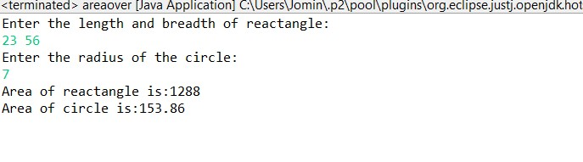

**Program 2**

06/05/2021

**Aim:** Create a class ‘Employee’ with data members Empid,

Name, Salary, Address and constructors to initialize the

data members. Create another class ‘Teacher’ that

inherit the properties of class employee and contain its

own data members department, Subjects taught and

constructors to initialize these data members and also

include display function to display all the data

members. Use array of objects to display details of N

teachers.

**Algorithm:**

Step 1: Start  
Step 2: Create a class employees  
Step 3: Create data members for empid, name salary, address  
Step 4: Create a constructor to initialize these data members  
Step 5: Create another class teacher which is inherited from   
Step 6: Create teacher class’s data members and initialize it with constructor  
Step 7: Create function to display ala datamembers  
Step 8: Create array of objects  
Step 9: call the display function to print all the data members  
Step 10: Stop

**Source Code:**

package Graphics;

import java.util.Scanner;

class employees{

int b;

String c;

String a;

int s;

public employees() {

Scanner obq=new Scanner(System.*in*);

Scanner obq1=new Scanner(System.*in*);Scanner obq2=new Scanner(System.*in*);

System.*out*.println("Enter the employee N.O :");

b=obq.nextInt();

System.*out*.println("Enter the employee Name :");

c=obq1.nextLine();

System.*out*.println("Enter the employee Address :");

a=obq2.nextLine();

System.*out*.println("Enter the employee salary:");

s=obq.nextInt();

}

public void edisplay() {

System.*out*.println("Employee N.O :"+b);

System.*out*.println("Employee Name :"+c);

System.*out*.println("Employee Address :"+a);

System.*out*.println("Employee salary:"+s);

}

}

class teachers extends employees {

String c,a;

public teachers() {

Scanner obq1=new Scanner(System.*in*);

Scanner obq2=new Scanner(System.*in*);

System.*out*.println("Enter the employee deparment :");

c=obq1.nextLine();

System.*out*.println("Enter the employee subject :");

a=obq2.nextLine();

}

void tdisplay() {

System.*out*.println("Employee deparment :"+c);

System.*out*.println("Employee subject :"+a);

}

}

class data extends teachers{

public data() {

}

public void display(int i) {

System.*out*.println("\n"+"----------"+i+"st Employee ---------"+"\n");

tdisplay();

edisplay();

}

}

public class emp{

public static void main(String[] args) {

int a;

Scanner obq=new Scanner(System.*in*);

System.*out*.println("Enter the number of employee :");

a=obq.nextInt();

data[] obj=new data[a];

for(int i=0;i<a;i++)

{

obj[i]=new data();

}

for(int i=0;i<a;i++)

{

obj[i].display(i+1);

}

}

}

**Output:**

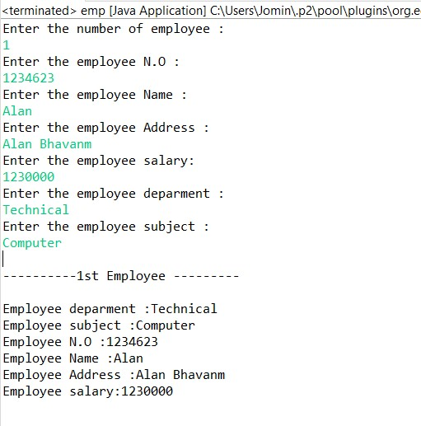

**Program 3**

06/05/2021

**Aim:** Create a class ‘Person’ with data members Name,

Gender, Address, Age and a constructor to initialize

the data members and another class ‘Employee’ that

inherits the properties of class Person and also contains

its own data members like Empid, Company_name,

Qualification, Salary and its own constructor. Create

another class ‘Teacher’ that inherits the properties of

class Employee and contains its own data members like

Subject, Department, Teacherid and also contain

constructors and methods to display the data members.

Use array of objects to display details of N teachers.

**Algorithm:**

Step 1: Start

Step 2: Create a class person with data members for name,

gender, address, age

Step 3: Create constructor to initialize these object

Step 4: Create another class Employee that inherited the

properties of class person and also creates its data

members like empid, companyname , qualification,

salary and its constructor

Step 5: Create another class Teacher that inherits the

properties of class employee and creates its data

members

Step 6: Creates array of object

Step 7: Using these arrays of objects print the values

Step 8: Stop

**Source Code:**

package packoops;

import java.util.Scanner;

class person{

String x,y,z;

int v;

public person() {

Scanner obq=new Scanner(System.*in*);

Scanner obq1=new Scanner(System.*in*);

Scanner obq2=new Scanner(System.*in*);

Scanner obq3=new Scanner(System.*in*);

System.*out*.println("Enter the Name :");

x=obq1.nextLine();

System.*out*.println("Enter the Gender :");

y=obq2.nextLine();

System.*out*.println("Enter the Address :");

z=obq3.nextLine();

System.*out*.println("Enter the employee Age:");

v=obq.nextInt();

}

}

class employees extends person {

int b;

String c;

String a;

int s;

public employees() {

Scanner obq=new Scanner(System.*in*);

Scanner obq1=new Scanner(System.*in*);Scanner obq2=new Scanner(System.*in*);

System.*out*.println("Enter the employee Id :");

b=obq.nextInt();

System.*out*.println("Enter the employee Company Name :");

c=obq1.nextLine();

System.*out*.println("Enter the employee Qualification :");

a=obq2.nextLine();

System.*out*.println("Enter the employee salary:");

s=obq.nextInt();

}

}

class teachers extends employees {

String c,a;

int p;

public teachers() {

Scanner obq1=new Scanner(System.*in*);

Scanner obq2=new Scanner(System.*in*);

Scanner obq3=new Scanner(System.*in*);

System.*out*.println("Enter the Deparment :");

c=obq1.nextLine();

System.*out*.println("Enter the Subject :");

a=obq2.nextLine();

System.*out*.println("Enter the Teacher Id :");

p=obq3.nextInt();

}

public void tdisplay() {

System.*out*.println("Deparment :"+c);

System.*out*.println("Subject :"+a);

System.*out*.println("Teacher Id :"+p);

}

}

class data extends teachers{

public data() {

}

public void display(int i) {

System.*out*.println("\n"+"----------"+i+"st Employee ---------"+"\n");

tdisplay();

}

}

public class corp{

public static void main(String[] args) {

int a;

Scanner obq=new Scanner(System.*in*);

System.*out*.println("Enter the number of Person to be added :");

a=obq.nextInt();

data[] obj=new data[a];

for(int i=0;i<a;i++)

{

obj[i]=new data();

}

for(int j=0;j<a;j++)

{

obj[j].display(j+1);

}

}

}

**Output:**

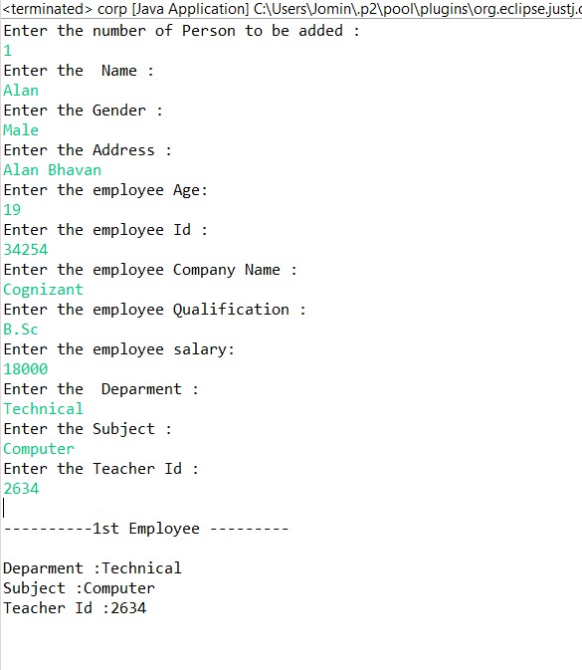

**Program 4**

06/05/2021

**Aim:** Write a program has class Publisher, Book, Literature

and Fiction. Read the information and print the details

of books from either the category, using inheritance.

**Algorithm:**

Step 1: Start

Step 2: Create a class publisher, Book, Literature and Fiction using inheritance  
Step 3: Create each class’s data members and member functions.  
Step 4: Read this information from the user  
Step 5: Print the details of book from the category  
Step 6: Stop.

**Source Code:**

package packoops;

import java.util.Scanner;

class publisher {

String p_name;

int p_year;

Scanner sc=new Scanner(System.*in*);

publisher()

{

System.*out*.println("Enter Publisher name");

p_name=sc.next();

System.*out*.println("Enter the Year of Publication");

p_year=sc.nextInt();

}

}

class book extends publisher {

String b_name,b_author;

int b_price;

Scanner sc=new Scanner(System.*in*);

book() {

System.*out*.println("Enter Book name");

b_name=sc.next();

System.*out*.println("Enter author");

b_author=sc.next();

System.*out*.println("Enter price");

b_price=sc.nextInt();

}

}

class literature extends book {

int page;

Scanner sc=new Scanner(System.*in*);

literature() {

System.*out*.println("Enter number of pages: ");

page=sc.nextInt();

}

void display(int i)

{

System.*out*.println("........"+i+"st LITERATURE ........");

System.*out*.println("Publisher name is "+p_name);

System.*out*.println("Published year is "+p_year);

System.*out*.println("Book name is "+b_name);

System.*out*.println("Autho name is "+b_author);

System.*out*.println("Price is "+b_price);

}

}

class fictions extends book {

int page;

Scanner sc=new Scanner(System.*in*);

fictions() {

System.*out*.println("Enter number of pages");

page=sc.nextInt();

}

void display(int i)

{

System.*out*.println("......... "+i+"st FICTION BOOK .........");

System.*out*.println("Publisher name is "+p_name);

System.*out*.println("Published year is "+p_year);

System.*out*.println("Book name is "+b_name);

System.*out*.println("Autho name is "+b_author);

System.*out*.println("Price is "+b_price);

}

}

public class inheritance {

public static void main(String[] args) {

int n,m,c,choice;

Scanner sc=new Scanner(System.*in*);

System.*out*.println("Choices");

System.*out*.println("1.literature.");

System.*out*.println("2.fiction.");

System.*out*.println("Enter the choice:");

choice=sc.nextInt();

switch(choice)

{

case 1:

System.*out*.println("Enter number of literatures books");

n=sc.nextInt();

literature l[]=new literature[n];

for(int i=0;i<n;i++) {

l[i]=new literature();

}

for(int i=0;i<n;i++) {

l[i].display(i+1);

}

break;

case 2:

System.*out*.println("Enter number of fictions books");

m=sc.nextInt();

fictions f[]=new fictions[m];

for(int i=0;i<m;i++) {

f[i]=new fictions();

}

for(int i=0;i<m;i++) {

f[i].display(i+1);

}

break;

default:

System.*out*.println("invalid choice");

break;

}

}

}

**Output:**

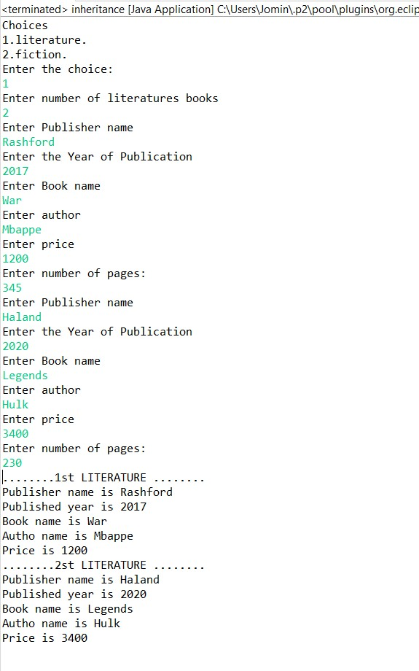

**Program 5**

06/05/2021

**Aim:** Create classes Student and Sports. Create another class

Result inherited from Student and Sports. Display the

academic and sports score of a student.

**Algorithm:**

Step 1: Start

Step 2: Create classes student and sports  
Step 3: Create another class Result inherited from Student and

Sports  
Step 4: Create a function called display to print  
Step 5: Display academic and sports score of student  
Step 6: Stop

**Source Code:**

package packoops;

import java.util.Scanner;

class student {

String name;

int maths,english,science;

Scanner sc=new Scanner(System.*in*);

public student() {

System.*out*.println("Enter the name of the student");

name=sc.next();

System.*out*.println("Enter the mark of Maths");

maths=sc.nextInt();

System.*out*.println("Enter the mark of English");

english=sc.nextInt();

System.*out*.println("Enter the mark of Science");

science=sc.nextInt();

}

}

class sports extends student{

String athletics,football,basketball;

public sports() {

System.*out*.println("Enter the Grade of athletics");

athletics=sc.next();

System.*out*.println("Enter the Grade of football");

football=sc.next();

System.*out*.println("Enter the Grade of basketball");

basketball=sc.next();

}

}

class result extends sports{

public result() {

}

int total=maths+english+science;

void display(){

System.*out*.println("------Marklist of "+name+"------");

System.*out*.println("Subject ");

System.*out*.println("Maths : "+maths);

System.*out*.println("English : "+english);

System.*out*.println("Science : "+science);

System.*out*.println("Total : "+total);

System.*out*.println("--Sports-- ");

System.*out*.println("Athletics : "+athletics);

System.*out*.println("Football : "+football);

System.*out*.println("Basketball : "+basketball);

}

}

public class acadamic {

public static void main(String[] args) {

int b;

Scanner obj1=new Scanner(System.*in*);

System.*out*.println("Enter the number of Person to be added :");

b=obj1.nextInt();

result[] obj=new result[b];

for(int i=0;i<b;i++)

{

obj[i]=new result();

}

for(int j=0;j<b;j++)

{

obj[j].display();

}

}

}

**Output:**

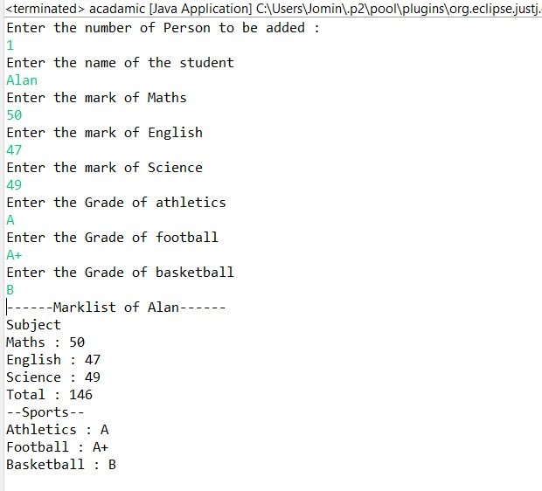

**Program 6**

06/05/2021

**Aim:** Create an interface having prototypes of functions

area() and perimeter(). Create two classes Circle and

Rectangle which implements the above interface.

Create a menu driven program to find area and

perimeter of objects.

**Algorithm:**

Step 1: Start

Step 2: Create an interface having prototypes of function

area() and perimeter()  
Step 3: Create classes that implements the interface  
Step 4: Create two classes circle and rectangle  
Step 5: find the perimeter and area of rectangle and circle  
Step 6: Print the results  
Step 7: Stop

**Source Code:**

package packoops;

import java.util.Scanner;

interface process{

void data();

void area();

void premeter();

}

class Circle implements process{

float r;

double area1,premeter1;

public void data()

{

Scanner obj=new Scanner(System.*in*);

System.*out*.println("Enter The radius Circle");

r=obj.nextInt();

}

public void area() {

area1=3.14*r*r;

System.*out*.println("Area:"+area1);

}

public void premeter() {

premeter1=2*3.14*r;

System.*out*.println("Premeter:"+premeter1);

}

}

class Rectangle implements process{

int l,b,area1,premeter1;

public void data()

{

Scanner obj=new Scanner(System.*in*);

System.*out*.println("Enter The Length of Rectangle");

l=obj.nextInt();

System.*out*.println("Enter The Breadth of Rectangle");

b=obj.nextInt();

//area1=l*b;

//premeter1=2*(l+b);

}

public void area() {

area1=l*b;

System.*out*.println("Area of Rectangle:"+area1);

}

public void premeter() {

premeter1=2*(l+b);

System.*out*.println("Premeter of Rectangle:"+premeter1);

}

}

public class diamension {

public static void main(String[] args) {

Rectangle obj1=new Rectangle();

Circle obj2=new Circle();

int r;

obj2.data();

obj2.area();

obj2.premeter();

obj1.data();

obj1.area();

obj1.premeter();

}

}

**Output:**

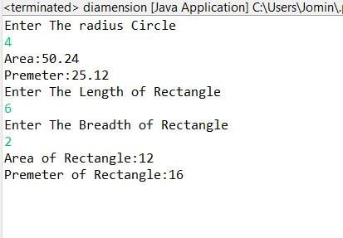

**Program 7**

06/05/2021

**Aim:** Prepare bill with the given format using calculate

method from interface. Order No.

Date :

Product Id Name Quantity unit price Total

101 A 2 25 50

102 B 1 100 100

Net. Amount 150

**Algorithm:**

STEP 1: Create a class Bill  
STEP 2: Create interface billing and create class section implements from billing.  
STEP 3: Create a display function  
STEP 4: Print the values as shown as the question  
STEP 5: Stop

**Source Code:**

package packoops;

import java.util.Scanner;

import java.time.format.DateTimeFormatter;

import java.time.LocalDateTime;

interface billing{

public void product();

public int calculation();

}

class section implements billing{

int prdtid,orderid,quanity,price,total;

String prdtname;

int pprice;

Scanner obj1=new Scanner(System.in);

public void product() {

System.out.println("Enter the Product Id");

prdtid=obj1.nextInt();

System.out.println("Enter the Product Name");

prdtname=obj1.next();

System.out.println("Enter the Quantity");

quanity=obj1.nextInt();

System.out.println("Enter the Price");

price=obj1.nextInt();

}

public int calculation() {

pprice =price*quanity;

return pprice;

}

public void display(int i) {

System.out.println(i+". "+"\t"+prdtid+"\t"+prdtname+"\t\t"+quanity+"\t"+price+" \t"+pprice);

}

}

public class Bill {

public static void main(String[] args) {

int p=0,ch=0,total=0,ttotal=0,count=0;

DateTimeFormatter dtf = DateTimeFormatter.ofPattern("yyyy/MM/dd \n\t\t\t\t\t HH:mm:ss");

LocalDateTime now = LocalDateTime.now();

Scanner obj=new Scanner(System.in);

section[] obj1 = new section[5] ;

System.out.println("Enter the Choice");

while(ch<3) {

System.out.println("1.Add"+"\t"+"2.Print"+"\t"+"3.Exit");

ch=obj.nextInt();

switch(ch) {

case 1:

count=count+1;

obj1[count] = new section();

obj1[count].product();

ttotal=obj1[count].calculation();

total=total+ttotal;

break;

case 2:

System.out.println("\t\t\t\tDate & Time: "+dtf.format(now));

System.out.println("Slno "+" Pdt_Id"+"\t"+"Pdt_Name"+"\t"+"Qty"+"\t"+"Rate" + "\t"+"Amount");

System.out.println("-----------------------------------------------");

for(int i=1;i<count+1;i++) {

obj1[i].display(i);

}

System.out.println("-----------------------------------------------");

System.out.println("\t\t\t\t\t total :"+total+"\n");

break;

default:

System.out.println("");

break;

}

}

}

}

**Output:**

